This time, we will discuss penalization based on the ℓ1\ell\_1ℓ1​ norm (the so-called Lasso regression).

First of all, one should admit that if the name stands for [least absolute shrinkage and selection operator](https://en.wikipedia.org/wiki/Lasso_(statistics)), that’s actually a very cool name… Funny story, a few years before, Leo Breiman introduce a concept of garrote technique… “The garrote eliminates some variables, shrinks others, and is relatively stable”.

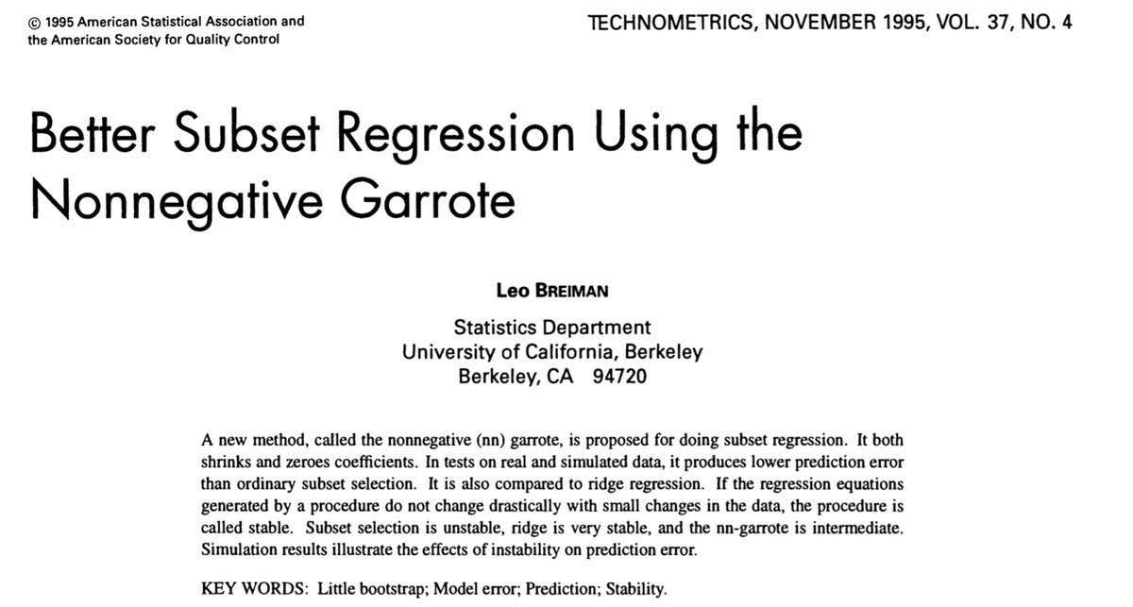

I guess that somehow, the lasso is the extension of the garotte technique

**Normalization of the covariates**

The first step will be to consider linear transformations of all covariates xjx\_jxj​ to get centered and scaled variables (with unit variance)

|  |
| --- |
| y = myocarde$PRONO  X = myocarde[,1:7]  **for**(j **in** 1:7) X[,j] = (X[,j]-**mean**(X[,j]))/**sd**(X[,j])  X = **as.matrix**(X) |

**Ridge Regression (from scratch)**

The heuristics about Lasso regression is the following graph. In the background, we can visualize the (two-dimensional) log-likelihood of the logistic regression, and the blue square is the constraint we have, if we rewite the optimization problem as a contrained optimization problem,

|  |
| --- |
| LogLik = **function**(bbeta){  b0=bbeta[1]  **beta**=bbeta[-1]  **sum**(-y\***log**(1 + **exp**(-(b0+X%\*%**beta**))) -  (1-y)\***log**(1 + **exp**(b0+X%\*%**beta**)))}  u = **seq**(-4,4,**length**=251)  v = **outer**(u,u,**function**(x,y) LogLik(**c**(1,x,y)))  **image**(u,u,v,**col**=**rev**(**heat.colors**(25)))  **contour**(u,u,v,add=TRUE)  **polygon**(**c**(-1,0,1,0),**c**(0,1,0,-1),border="blue") |

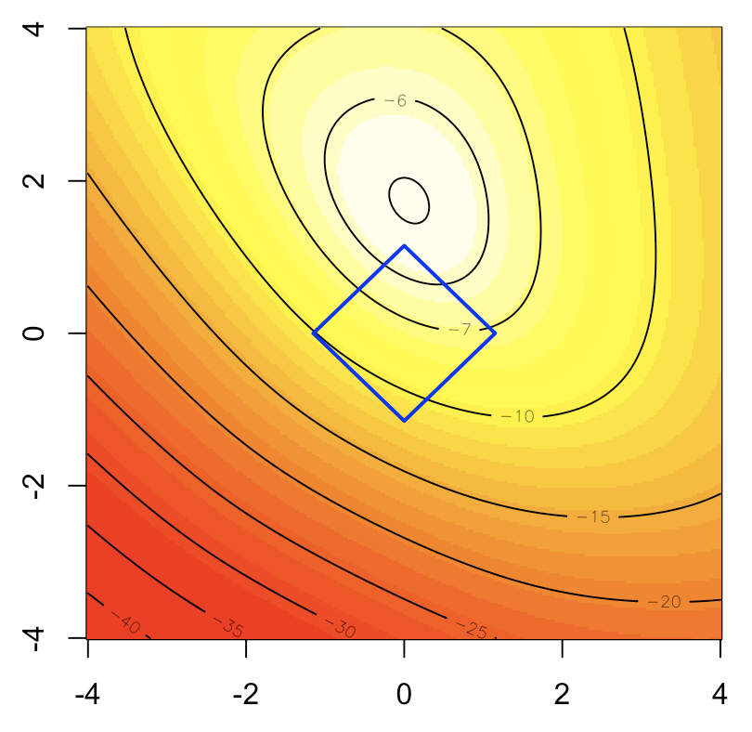

The nice thing here is that is works as a variable selection tool, since some components can be null here. That’s the idea behind the following (popular) graph

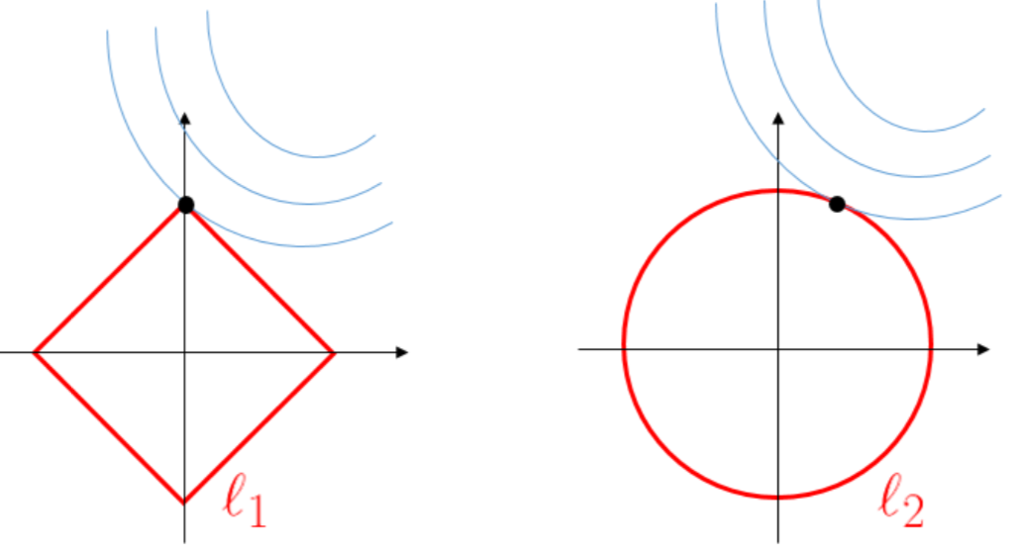  
(with lasso on the left, and ridge on the right).

Heuristically, the maths explanation is the following. Consider a simple regression yi=xiβ+εy\_i=x\_i\beta+\varepsilonyi​=xi​β+ε, with ℓ1\ell\_1ℓ1​-penality and a ℓ2\ell\_2ℓ2​-loss fuction. The optimization problem becomesmin⁡{yTy−2yTxβ+βxTxβ+2λ∣β∣}\min\big\{\mathbf{y}^T\mathbf{y}-2\mathbf{y}^T\mathbf{x}\beta+\beta\mathbf{x}^T\mathbf{x}\beta+2\lambda{\color{red}{|}}\beta{\color{red}{|}}\big\}min{yTy−2yTxβ+βxTxβ+2λ∣β∣}The first order condition can be written−2yTx+2xTxβ^±2λ=0-2\mathbf{y}^T\mathbf{x}+2\mathbf{x}^T\mathbf{x}\widehat{\beta}{\color{red}{\pm} }2\lambda=0−2yTx+2xTxβ

​±2λ=0(the sign in ±{\color{red}{\pm}}± being the sign of β^\widehat{\beta}β​).  
Assume that yTx>0\mathbf{y}^T\mathbf{x}>0yTx>0, then solution is  
β^λlasso=max⁡{yTx−λxTx,0}\widehat{\beta}\_{\lambda}^{lasso}=\max\left\lbrace\frac{\mathbf{y}^T\mathbf{x}-\lambda}{\mathbf{x}^T\mathbf{x}},0\right\rbraceβ

​λlasso​=max{xTxyTx−λ​,0}(we get a corner solution when λ\lambdaλ is large).

**Optimization routine**

As in our previous post, let us start with standard (R) optimization routines, such as [BFGS](https://en.wikipedia.org/wiki/Broyden%E2%80%93Fletcher%E2%80%93Goldfarb%E2%80%93Shanno_algorithm)

|  |
| --- |
| PennegLogLik = **function**(bbeta,lambda=0){  b0=bbeta[1]  **beta**=bbeta[-1]  -**sum**(-y\***log**(1 + **exp**(-(b0+X%\*%**beta**))) -  (1-y)\***log**(1 + **exp**(b0+X%\*%**beta**)))+lambda\***sum**(**abs**(**beta**))  }  opt\_lasso = **function**(lambda){  beta\_init = **lm**(PRONO~.,**data**=myocarde)$coefficients  logistic\_opt = **optim**(**par** = beta\_init\*0, **function**(x) PennegLogLik(x,lambda),  hessian=TRUE, method = "BFGS", control=**list**(abstol=1e-9))  logistic\_opt$par[-1]  }  v\_lambda=**c**(**exp**(**seq**(-4,2,**length**=61)))  est\_lasso=**Vectorize**(opt\_lasso)(v\_lambda)  **library**("RColorBrewer")  colrs=brewer.pal(7,"Set1")  **plot**(v\_lambda,est\_lasso[1,],**col**=colrs[1],type="l")  **for**(i **in** 2:7) **lines**(v\_lambda,est\_lasso[i,],**col**=colrs[i],lwd=2) |

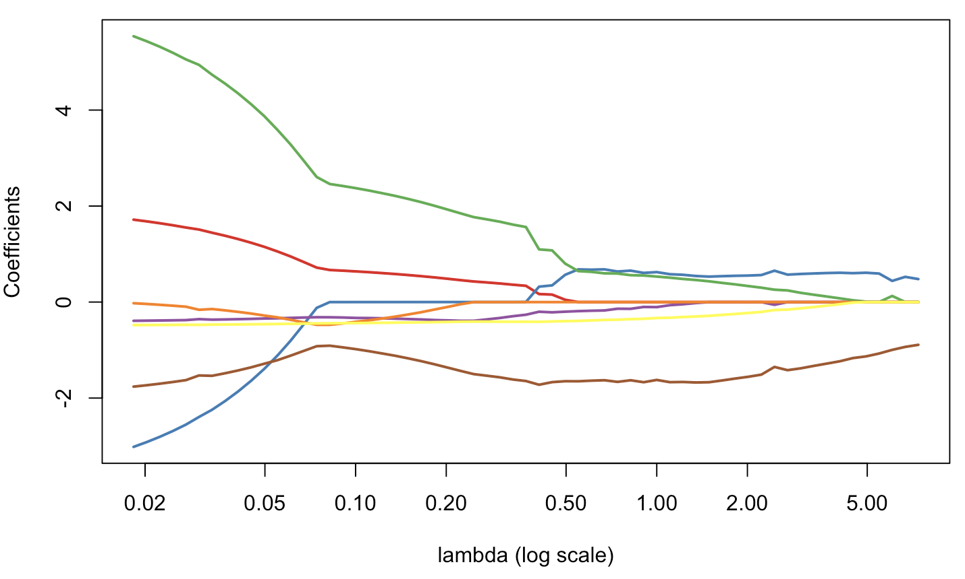  
But it is very heratic… or non stable.

**Using glmnet**

Just to compare, with R routines dedicated to lasso, we get the following

|  |
| --- |
| **library**(glmnet)  glm\_lasso = glmnet(X, y, alpha=1)  **plot**(glm\_lasso,xvar="lambda",**col**=colrs,lwd=2) |

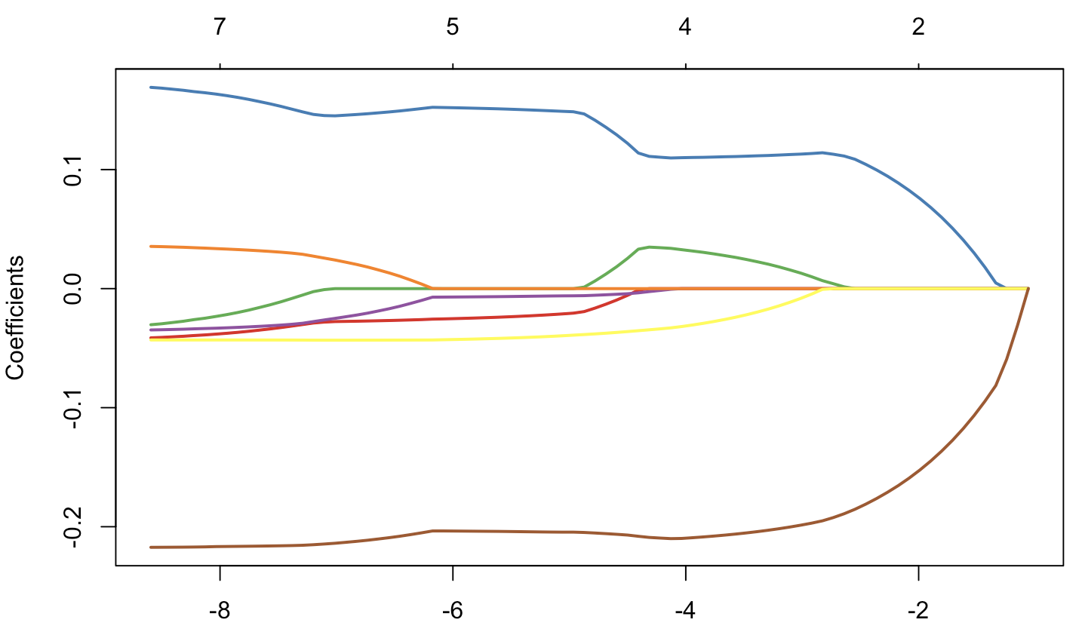

|  |
| --- |
| **plot**(glm\_lasso,**col**=colrs,lwd=2) |

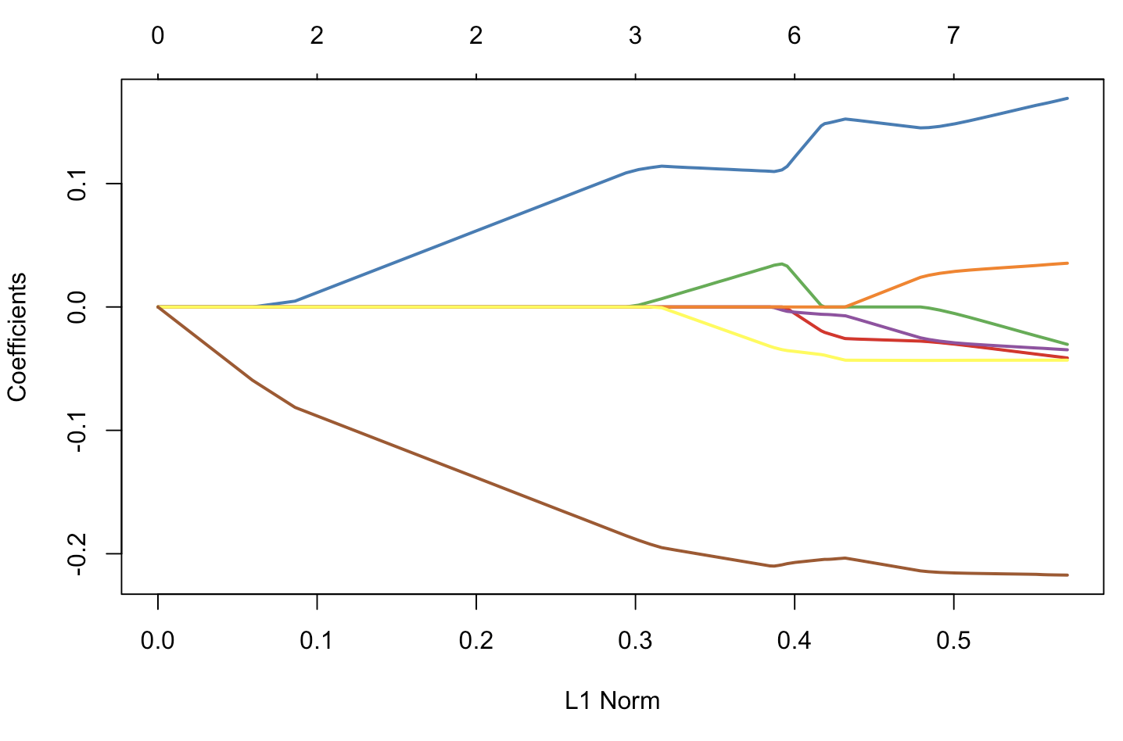

If we look carefully what’s in the ouput, we can see that there is variable selection, in the sense that some β^j,λ=0\widehat{\beta}\_{j,\lambda}=0β

​j,λ​=0, in the sense “really null”

|  |
| --- |
| glmnet(X, y, alpha=1,lambda=**exp**(-4))$beta  7x1 sparse Matrix of **class** "dgCMatrix"  s0  FRCAR .  INCAR 0.11005070  INSYS 0.03231929  PRDIA .  PAPUL .  PVENT -0.03138089  REPUL -0.20962611 |

Of course, with out optimization routine, we cannot expect to have null values

|  |
| --- |
| opt\_lasso(.2)  FRCAR INCAR INSYS PRDIA  0.4810999782 0.0002813658 1.9117847987 -0.3873926427  PAPUL PVENT REPUL  -0.0863050787 -0.4144139379 -1.3849264055 |

So clearly, it will be necessary to spend more time today, to understand how it works…

**Orthogonal covariates**

Before getting into the maths, observe that when covariates are orthogonal, there is some very clear “variable” selection process,

|  |
| --- |
| **library**(factoextra)  pca = **princomp**(X)  pca\_X = get\_pca\_ind(pca)$coord  glm\_lasso = glmnet(pca\_X, y, alpha=1)  **plot**(glm\_lasso,xvar="lambda",**col**=colrs)  **plot**(glm\_lasso,**col**=colrs) |

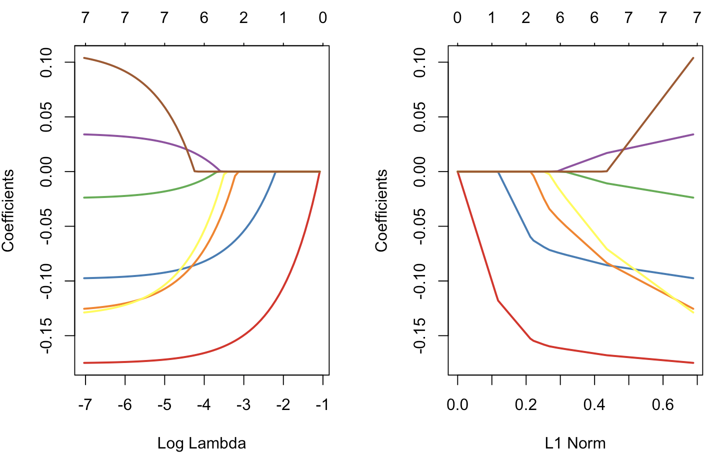

**Interior Point approach**

The penalty is now expressed using the ℓ1\ell\_1ℓ1​ so intuitively, it should be possible to consider algorithms related to linear programming. If I can find some time, later one, maybe I will try to recode it. But actually, it is not the technique used in most R functions.

Now, o be honest, we face a double challenge today: the first one is to understand how lasso works for the “standard” (least square) problem, the second one is to see how to adapt it to the logistic case.

Detailed Specification

**Introduction**

l1\_logreg is an implementation of the interior-point method for l1-regularized logistic regression. This implementation consists of three main functions:

* l1\_logreg\_train for training
* l1\_logreg\_classify for classification
* l1\_logreg\_regpath for (approximate) regularization path computation

l1\_logreg concerns the *logistic model* that has the form

\[ \mbox{Prob}(b|x) = \frac{\exp(b(w^Tx+v))}{1+\exp(b(w^Tx+v))}, \]

where $x\in\mathbf{R}^n$ denotes a vector of feature variables, and $b\in\{-1,+1\}$ denotes the associated binary outcome (class). Here, $\mbox{Prob}(b|x)$ is the conditional probability of $b$, given $x$. The logistic model has parameters $v\in\mathbf{R}$ (the intercept) and $w\in\mathbf{R}^n$ (the weight vector).

With a given set of training examples,

\[ (x_i,b_i)\in \mathbf{R}^n \times \{-1,+1\},~i=1,\ldots,m, \]

l1\_logreg\_train finds the logistic model by solving an optimization problem of the form

\[ \begin{array}{ll}\mbox{minimize} & (1/m)\sum_{i=1}^m \log\left(1+\exp(-b_i(x_i^Tw+v))\right) + \lambda \sum_{i=1}^n |w_i|, \end{array} \]

where the variables are $w \in \mathbf R^n$, $v \in \mathbf R$, and the problem data are $x_i$, $b_i$ and $\lambda >0$. We refer to the problem as a *$l_1$-regularized logistic regression problem* (l1-regularized LRP).

Once we find maximum likelihood values of $v$ and $w$, *i.e.*, a solution of the l1-regularized LRP, we can predict the probability of the two possible outcomes, $\mbox{Prob}(\pm 1|x)$, given a new feature vector $x\in\mathbf{R}^n$, using the associated logistic model.

l1\_logreg\_classify performs classification over a (test) data set $ \{\tilde{x}_i\in\mathbf{R}^n:~i=1,\ldots,\tilde{m}\}$ by computing

\[ \hat{b}_i = \mbox{sgn}\left(\tilde{x}_i^Tw+v\right),\quad~i=1,\ldots,\tilde{m}, \]

which picks the more likely outcome, given $x_i$, according to the logistic model found by l1\_logreg\_train.

The regularization parameter $\lambda$ roughly controls the number of nonzero components in $w$, with larger $\lambda$ typically yielding sparser $w$. The family of solutions, as $\lambda$ varies over $(0,\infty)$ is called the *regularization path*. l1\_logreg\_regpath finds an approximate regularization path efficiently using a warmstart technique.

To solve the l1-regularized LRP, l1\_logreg uses Preconditioned Conjugate Gradient (PCG) method if the feature matrix is stored in sparse format, and the direct method if the feature matrix is stored in dense format. For more information on file format, see **file format** page.

**Features**

l1\_logreg

* can handle both dense and sparse problems.
* can handle large-scale (sparse) problems (with a million features and examples).
* supports various external **BLAS and LAPACK libraries** (ATLAS, MKL, ACML and so on).
* can apply standardization to sparse data efficiently.

**How to use the package**

You can use the package in different ways.

* The easiest method is to use the stand-alone executables l1\_logreg\_train, l1\_logreg\_classify and l1\_logreg\_regpath in the command line.
* Write a C-program that calls the function l1\_logreg\_train and l1\_logreg\_train in **src\_c/l1\_logreg.c**.
* It is also callable from Matlab, using Matlab system call.
* We hope to add an R interface soon.

**Installation**

To use l1\_logreg, you need to get executables compatible with your machine. You may download precompiled executables or download the source code to build your own.

To install precompiled executables, you can simply download executables compatible with your OS and CPU.

**Download**

l1\_logreg is distributed under the terms of the **GNU General Public License 2.0**. For commercial applications that may be incompatible with this license, please do not hesitate to contact us to discuss alternatives.

To obtain the l1\_logreg distribution, which includes the source code, the manual, and example data sets, use the following links:

* Source package: **l1\_logreg-0.8.2.tar.gz (352K)**

If you just want binaries, you can download them from the following links:

* Binaries for Intel/AMD Linux: **l1\_logreg-0.8.2-i686-pc-linux-gnu.tar.gz (2.4M)**
* Binaries for Intel MAC OS X (10.5): **l1\_logreg-0.8.2-i686-apple-darwin9.7.0.tar.gz (88K)**

If you want to run examples, download and untar the source package first, and put the executables in the binary package at src\_c directory. For test, run test\_script at the top-build directory of source package after putting/making the binaries in src\_c directory.

NOTE: The pre-compiled binaries would be slow. To achieve maximum performance you might want to compile the source code using BLAS appropriate to your own machine.

Before installation, be sure that BLAS and LAPACK libraries are installed in your machine. If not (or not sure), please check the **libraries** page.

**Usage**

**Using l1\_logreg in shell**

Typical usage of l1\_logreg\_train is:

l1\_logreg\_train -s train\_x train\_b 0.01 model

It performs training, that is learning a logistic model from training examples of feature matrix train\_x and class vector train\_b with $\lambda$= 0.01. The model learned from example data are stored in model.

Typical usage of l1\_logreg\_classify is:

l1\_logreg\_classify model test\_x result

It classifies the test data using the logistic model parameters stored in model and store the classification result to result file. If you want to not only classify the test data, but also compare the result with a known class vector test\_b, use the -t option:

l1\_logreg\_classify -t test\_b model test\_x results

**Using l1\_logreg in Matlab**

l1\_logreg is callable from Matlab. You may write the problem data (feature matrix and class vector) first using mmwrite script; see **writing matrices in Matrix Market (MM) format using Matlab** page. You may call stand-alone executables using Matlab system call. For example,

mmwrite('ex\_X',X);

mmwrite('ex\_b',b);

system('l1\_logreg\_train -s ex\_X ex\_b 0.01 model\_iono')

...

model\_iono = mmread('model\_iono');

You may assign the result file to a Matlab variable using mmread script. For example,

system('l1\_logreg\_classify -t ex\_b model\_iono ex\_X result\_iono')

...

model\_iono = mmread('result\_iono');

**Calling sequence for training**

Calling sequence for l1\_logreg\_train is

l1\_logreg\_train [options] feature\_file class\_file lambda model\_file

Arguments are

feature\_file - feature matrix

class\_file - output vector

lambda - regularization parameter

model\_file - store model data to file model\_file

Options are

-q - quiet mode

-v [0..3] - set verbosity level (default 1)

0 : show one line summary

1 : show simple log

3 : show detailed log

-r - use relative lambda

if used, lambda := lambda\*lambda\_max

if not used, lambda := lambda

-s - standardize data

Advanced options are

-h - show coefficients histogram and trim

-k <double> - set tolerance for zero coefficients from KKT

condition

-t <double> - set tolerance for duality gap

See **file format** page for the formats of feature\_file, class\_file and out\_file.

**Calling sequence for classification**

Calling sequence for l1\_logreg\_classify is:

l1\_logreg\_classify [options] model\_file feature\_file result\_file

Arguments are:

model\_file - model data(coefficients and intercept)

found by either l1\_logreg\_train or

l1\_logreg\_regpath

feature\_file - feature matrix

result\_file - store classification results to result\_file

if model\_file is generated from

1) l1\_logreg\_train, then predicted outcomes

2) l1\_logreg\_regpath, then the number of errors

will be stored.

Options are:

-q - quiet mode

-p - store probability instead of predicted outcome

-t <class\_file> - test classification result

against real class vector in <class\_file>

See **file format** page for the formats of feature\_file, class\_file and out\_file.

**Calling sequence for regularization path computation**

Calling sequence for l1\_logreg\_regpath is:

l1\_logreg\_regpath [options] feature\_file class\_file lambda\_min num\_lambda model\_file

Arguments are:

feature\_file - feature matrix

class\_file - output vector

lambda\_min - minimum value of regularization parameter

num\_lambda - number of lambdas (sample)

model\_file - store results to file model\_file

Options are:

-c - only coefficients (to know real coefficients).

The model\_file generated with -c option cannot

be used for classification.

Use this option only to plot regularization path.

-q - quiet mode

-v [0..3] - set verbosity level

0 : show one line summary

1 : show simple log

3 : show detailed log

-r - use relative lambda

if used, lambda := lambda\*lambda\_max

if not used, lambda := lambda

-s - standardize data

Advanced options are

-k <double> - set tolerance for zero coefficients from KKT

condition

-t <double> - set tolerance for duality gap

See **file format** page for the formats of feature\_file, class\_file and out\_file.

**Example**

* **Training**
* **Classification**
* **Regularization path computation**

**Training**

Consider a small problem with 3 examples and 4 features:

feature 1 feature 2 feature 3 feature 4 class

example 1 3 0 1 -2 1

example 2 0 0 2 5 -1

example 3 7 1 -4 0 1

To solve associated l1-regularized LRP, a user stores a feature matrix and a class vector in MM format. Feature matrix can be stored in either array (dense) format and coordinate (sparse) format. If the problem is stored in dense format, l1\_logreg\_train uses direct methods. If stored in sparse format, l1\_logreg\_train uses the PCG method in solving the problem.

The associated feature matrix can be stored in the file train\_x in dense format.

**train\_x**

%%MatrixMarket matrix array real general

3 4

3

0

7

0

0

1

1

2

-4

-2

5

0

The associated feature matrix can be stored in the file train\_x in sparse format.

**train\_x**

%%MatrixMarket matrix coordinate real general

3 4 8

1 1 3

3 1 7

3 2 1

1 3 1

2 3 2

3 3 -4

1 4 -2

2 4 5

A class file must be stored in array (dense) format for both direct and PCG methods.

**train\_b**

%%MatrixMarket matrix array real general

3 1

1

-1

1

To standardize training data train\_x and to learn a model with $\lambda=0.01$ from the standardized training data, execute the following command:

l1\_logreg\_train -s train\_x train\_b 0.01 model

This will generate the following file model:

**model**

%MatrixMarket matrix array real general

%

% This is a model file of train\_x,

% generated by l1\_logreg\_train ver.0.8.2

% Contents of model:

% entry 1: intercept

% entries 2..m: coefficients

%

5 1

1.568009374292901e+00

4.043495151532541e-01

0.000000000000000e+00

0.000000000000000e+00

-1.103257200261706e+00

**Classification**

Consider a small test data set of 2 examples with 4 features:

feature 1 feature 2 feature 3 feature 4

example 1 5 1 0 0

example 2 -3 0 2 3

The test data set can be stored in the file test\_x in dense format.

**test\_x**

%MatrixMarket matrix array real general

2 4

5

-3

1

0

0

2

0

3

The test data set can be stored in the file test\_x in sparse format.

**test\_x**

%MatrixMarket matrix coordinate real general

2 4 5

1 1 5

2 1 -3

1 2 1

2 3 2

2 4 3

To classify the test data set using the logistic model stored in model, execute the following command:

l1\_logreg\_classify model test\_x result

The classification result will be saved in the file result.

**result**

%MatrixMarket matrix array real general

%

% This is the file that stores the test result of test\_x,

% generated by l1\_logreg\_classify ver 0.8.2

% Each row contains a predicted class of corresponding example.

%

2 1

1

-1

To compare the predicted outcome which will be stored in the result file result with the known outcome test\_b, write the known outcome (class) vector file test\_b in MM format and execute the following command:

l1\_logreg\_classify -t test\_b model test\_x result

**Regularization path computation**

To generate an approximation of the regularization path, from $\lambda_{\max}$ to a given $\lambda=0.01\lambda_{\max}$, use

l1\_logreg\_regpath -r train\_x train\_b 0.01 100 path\_model

It generates two files: path\_model and path\_model\_lambda. The former contains a matrix of models whose column corresponds to the logistic model for each $\lambda$ value. The latter contains a vector of $\lambda$ values. The option -r is used to set $\lambda$ value relative to $\lambda_{\max}$.

To apply classification to this family of models path\_model, execute the following command:

l1\_logreg\_classify -t train\_b path\_model train\_x path\_result

The number of examples whose prediction is wrong will be stored to a result file path\_result. Note that the result of classification using l1\_logreg\_regpath is different from that of l1\_logreg\_train.

**Standard lasso (with weights)**

If we get back to the original Lasso approach, the goal was to solvemin⁡{12n∑i=1n[yi−(β0+xiTβ)]2+λ∑j∣βj∣}\min\left\lbrace\frac{1}{2n}\sum\_{i=1}^n [y\_i-(\beta\_0+\mathbf{x}\_i^T\mathbf{\beta})]^2+\lambda \sum\_j |\beta\_j|\right\rbracemin{2n1​i=1∑n​[yi​−(β0​+xiT​β)]2+λj∑​∣βj​∣}(with standard notions, as in [wikipedia](https://en.wikipedia.org/wiki/Lasso_(statistics)) – most of the code in this section is inspired by Jocelyn’s great post).

Observe that the intercept is not subject to the penalty. The first order condition is then∂∂β0∥y−Xβ−β01∥2=(Xβ−y)T1+β0∥1∥2=0\frac{\partial}{\partial\beta\_0}\|\mathbf{y}-\mathbf{X}\mathbf{\beta}-\beta\_0\mathbf{1}\|^2=(\mathbf{X}\mathbf{\beta}-\mathbf{y})^T\mathbf{1}+\beta\_0\|\mathbf{1}\|^2=0∂β0​∂​∥y−Xβ−β0​1∥2=(Xβ−y)T1+β0​∥1∥2=0i.e.β0=1n2(Xβ−y)T1\beta\_0=\frac{1}{n^2}(\mathbf{X}\mathbf{\beta}-\mathbf{y})^T\mathbf{1}β0​=n21​(Xβ−y)T1Assume now that [KKT conditions](https://en.wikipedia.org/wiki/Karush%E2%80%93Kuhn%E2%80%93Tucker_conditions) are satisfied, since we cannot differentiate (to find points where the gradient is 0\mathbf{0}0), we can check if 0\mathbf{0}0 contains the subdifferential at the minimum.  
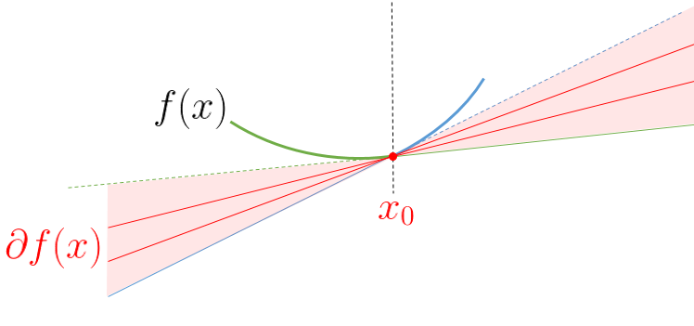

Namely0∈∂(12∥y−Xβ∥2+λ∥β∥ℓ1)=12∇∥y−Xβ∥2+∂(λ∥β∥ℓ1)\mathbf{0}\in\partial \left(\frac{1}{2}\|\mathbf{y}-\mathbf{X}\mathbf{\beta}\|^2+\lambda\|\mathbf{\beta}\|\_{\ell\_1}\right)=\frac{1}{2}\nabla\|\mathbf{y}-\mathbf{X}\mathbf{\beta}\|^2+\partial(\lambda\|\mathbf{\beta}\|\_{\ell\_1})0∈∂(21​∥y−Xβ∥2+λ∥β∥ℓ1​​)=21​∇∥y−Xβ∥2+∂(λ∥β∥ℓ1​​)  
For the term on the left, we recognize 12∇∥y−Xβ∥2=−XT(y−Xβ)=−g\frac{1}{2}\nabla\|\mathbf{y}-\mathbf{X}\mathbf{\beta}\|^2=-\mathbf{X}^T(\mathbf{y}-\mathbf{X}\mathbf{\beta})=-\mathbf{g}21​∇∥y−Xβ∥2=−XT(y−Xβ)=−gso that the previous equation can be writengk∈∂(λ∣βk∣)={{+λ} if βk>0{−λ} if βk<0(−λ,+λ) if βk=0g\_k\in\partial(\lambda|\beta\_k|)=\begin{cases}\{+\lambda\}\text{ if }\beta\_k>0 \\ \{-\lambda\}\text{ if }\beta\_k<0 \\ (-\lambda,+\lambda)\text{ if }\beta\_k=0\end{cases}gk​∈∂(λ∣βk​∣)=⎩⎪⎪⎨⎪⎪⎧​{+λ} if βk​>0{−λ} if βk​<0(−λ,+λ) if βk​=0​i.e. if βk≠0\beta\_k\neq 0βk​​=0, then gk=sign(βk)⋅λg\_k = \text{sign}(\beta\_k)\cdot\lambdagk​=sign(βk​)⋅λ.

Then we write the [KKT conditions](https://en.wikipedia.org/wiki/Karush%E2%80%93Kuhn%E2%80%93Tucker_conditions) for this formulation and simplify them to produce a set of rules for checking our solution

We can split βj\beta\_jβj​ into a sum of its positive and negative parts by replacing βj\beta\_jβj​ with βj+−βj−\beta\_j^+-\beta\_j^-βj+​−βj−​ where βj+,βj−≥0\beta\_j^+,\beta\_j^-\geq0βj+​,βj−​≥0. Then the Lasso problem becomes−log⁡L(β)+λ∑j(βj+−βj−)-\log\mathcal{L}(\mathbf{\beta})+\lambda\sum\_j(\beta\_j^+-\beta\_j^-)−logL(β)+λj∑​(βj+​−βj−​)with constraints βj+−βj−\beta\_j^+-\beta\_j^-βj+​−βj−​.

Let αj+,αj−\alpha\_j^+,\alpha\_j^-αj+​,αj−​ denote the Lagrange multipliers for βj+,βj−\beta\_j^+,\beta\_j^-βj+​,βj−​, respectively.

L(β)+λ∑j(βj+−βj−)−∑jαj+βj+−∑jαj−βj−.L({\mathbf{\beta}}) + \lambda \sum\_{j} (\beta\_{j}^{+} - \beta\_{j}^{-}) - \sum\_{j}\alpha\_{j}^{+}\beta\_{j}^{+} - \sum\_{j} \alpha\_{j}^{-}\beta\_{j}^{-}.L(β)+λj∑​(βj+​−βj−​)−j∑​αj+​βj+​−j∑​αj−​βj−​.To satisfy the stationarity condition, we take the gradient of the Lagrangian with respect to βj+\beta\_{j}^{+}βj+​ and set it to zero to obtain∇L(β)j+λ−αj+=0\nabla L({\mathbf{\beta}})\_{j} + \lambda - \alpha\_{j}^{+} = 0∇L(β)j​+λ−αj+​=0We do the same with respect to βj−\beta\_{j}^{-}βj−​ to obtain−∇L(β)j+λ−αj−=0-\nabla L({\mathbf{\beta}})\_{j}+\lambda-\alpha\_{j}^{-} = 0−∇L(β)j​+λ−αj−​=0

Primal feasibility requires that the primal constraints be satisfied so this gives us βj+≥0\beta\_{j}^{+} \ge 0βj+​≥0 and βj−≥0\beta\_{j}^{-} \ge 0βj−​≥0. Then dual feasibility requires non-negativity of the Lagrange multipliers so we get αj+≥0\alpha\_{j}^{+} \ge 0αj+​≥0 and αj−≥0\alpha\_{j}^{-} \ge 0αj−​≥0. And finally, complementary slackness requires that αj+βj+=0\alpha\_{j}^{+}\beta\_{j}^{+} = 0αj+​βj+​=0 and αj−βj−=0\alpha\_{j}^{-}\beta\_{j}^{-} = 0αj−​βj−​=0. We can simplify these conditions to obtain a simple set of rules for checking whether or not our solution is a minimum.

From ∇L(β)j+λ−αj+=0\nabla L(\beta)\_{j} + \lambda - \alpha\_{j}^{+} = 0∇L(β)j​+λ−αj+​=0, we have ∇L(β)j+λ=αj+≥0\nabla L(\beta)\_{j} + \lambda= \alpha\_{j}^{+} \ge 0∇L(β)j​+λ=αj+​≥0. This gives us ∇L(β)j≥−λ\nabla L(\beta)\_{j} \ge -\lambda∇L(β)j​≥−λ. From −∇L(β)j+λ−αj−=0-\nabla L(\beta)\_{j} + \lambda - \alpha\_{j}^{-} = 0−∇L(β)j​+λ−αj−​=0, we have −∇L(β)j+λ=αj−≥0-\nabla L(\beta)\_{j} + \lambda = \alpha\_{j}^{-} \ge 0−∇L(β)j​+λ=αj−​≥0. This gives us −∇L(β)j≥−λ-\nabla L(\beta)\_{j} \ge -\lambda−∇L(β)j​≥−λ, which gives us ∇L(β)j≤λ\nabla L(\beta)\_{j} \le \lambda∇L(β)j​≤λ. Hence, ∣∇L(β)j∣≤λ  ∀j\lvert \nabla L(\beta)\_{j} \rvert \le \lambda \; \forall j∣∇L(β)j​∣≤λ∀j

When βj+>0,λ>0\beta\_{j}^{+} > 0, \lambda > 0βj+​>0,λ>0, complementary slackness requires αj+=0\alpha\_{j}^{+} = 0αj+​=0. So ∇L(β)j+λ=αj+=0\nabla L(\beta)\_{j} + \lambda = \alpha\_{j}^{+} = 0∇L(β)j​+λ=αj+​=0. Hence, ∇L(β)j=−λ<0\nabla L(\beta)\_{j} = -\lambda < 0∇L(β)j​=−λ<0 since λ>0\lambda > 0λ>0. At the same time, −∇L(β)j+λ=αj−≥0-\nabla L(\beta)\_{j} + \lambda = \alpha\_{j}^{-} \ge 0−∇L(β)j​+λ=αj−​≥0 so 2λ=αj−>02 \lambda = \alpha\_{j}^{-} > 02λ=αj−​>0 since λ>0\lambda > 0λ>0. Then complementary slackness requires βj−=0\beta\_{j}^{-} = 0βj−​=0. Hence, when βj+>0\beta\_{j}^{+} > 0βj+​>0, we have βj−=0\beta\_{j}^{-}=0βj−​=0 and ∇L(β)j=−λ\nabla L(\beta)\_{j} = -\lambda∇L(β)j​=−λ

Similarly, when βj−>0,λ>0\beta\_{j}^{-} > 0, \lambda > 0βj−​>0,λ>0, complementary slackness requires αj−=0\alpha\_{j}^{-}=0αj−​=0. So −∇L(β)j+λ=αj−=0-\nabla L(\beta)\_{j} + \lambda = \alpha\_{j}^{-} = 0−∇L(β)j​+λ=αj−​=0 and ∇L(β)j=λ>0\nabla L(\beta)\_{j}=\lambda>0∇L(β)j​=λ>0 since λ>0\lambda > 0λ>0. Then from ∇L(β)j+λ=αj+≥0\nabla L(\beta)\_{j} + \lambda = \alpha\_{j}^{+} \ge 0∇L(β)j​+λ=αj+​≥0 and the above, we get 2λ=αj+>02 \lambda = \alpha\_{j}^{+} > 02λ=αj+​>0. Then complementary slackness requires βj+=0\beta\_{j}^{+} = 0βj+​=0. Hence, when βj−>0\beta\_{j}^{-} > 0βj−​>0, we have βj+=0\beta\_{j}^{+}=0βj+​=0 and ∇L(β)j=λ\nabla L(\beta)\_{j} = \lambda∇L(β)j​=λ.

Since βj=βj+−βj−\beta\_{j} = \beta\_{j}^{+} - \beta\_{j}^{-}βj​=βj+​−βj−​, this means that when βj>0\beta\_{j} > 0βj​>0, ∇L(β)j=−λ\nabla L(\beta)\_{j} = -\lambda∇L(β)j​=−λ. And when βj<0\beta\_{j} <0βj​<0, ∇L(β)j=λ\nabla L(\beta)\_{j} = \lambda∇L(β)j​=λ. Combining this with ∣∇L(β)j∣≤λ  ∀j\lvert \nabla L(\beta)\_{j} \rvert \le \lambda \; \forall j∣∇L(β)j​∣≤λ∀j, we arrive at the same convergence requirements that we obtained before using subdifferential calculus.

For conveniency, introduce the soft-thresholding functionS(z,γ)=sign(z)⋅(∣z∣−γ)+={z−γ if γ>∣z∣ and z<0z+γ if γ<∣z∣ and z<00 if γ≥∣z∣S(z,\gamma)=\text{sign}(z)\cdot(|z|-\gamma)\_+=\begin{cases}z-\gamma&\text{ if }\gamma>|z|\text{ and }z<0\\z+\gamma&\text{ if }\gamma<|z|\text{ and }z<0 \\0&\text{ if }\gamma\geq|z|\end{cases}S(z,γ)=sign(z)⋅(∣z∣−γ)+​=⎩⎪⎪⎨⎪⎪⎧​z−γz+γ0​ if γ>∣z∣ and z<0 if γ<∣z∣ and z<0 if γ≥∣z∣​  
Noticing that the optimization problem 12∥y−Xβ∥ℓ22+λ∥β∥ℓ1\frac{1}{2}\|\mathbf{y}-\mathbf{X}\mathbf{\beta}\|\_{\ell\_2}^2+\lambda\|\mathbf{\beta}\|\_{\ell\_1}21​∥y−Xβ∥ℓ2​2​+λ∥β∥ℓ1​​can also be written  
min⁡{∑j=1p−β^jols⋅βj+12βj2+λ∣βj∣}\min\left\lbrace\sum\_{j=1}^p -\widehat{\beta}\_j^{ols}\cdot\beta\_j+\frac{1}{2}\beta\_j^2+\lambda|\beta\_j|\right\rbracemin{j=1∑p​−β

​jols​⋅βj​+21​βj2​+λ∣βj​∣}observe thatβ^j,λ=S(β^jols,λ)\widehat{\beta}\_{j,\lambda}=S(\widehat{\beta}\_j^{ols},\lambda)β​j,λ​=S(β

​jols​,λ)which is a coordinate-wise update.

Now, if we consider a (slightly) more general problem, with weights in the first partmin⁡{12n∑i=1nωi[yi−(β0+xiTβ)]2+λ∑j∣βj∣}\min\left\lbrace\frac{1}{2n}\sum\_{i=1}^n{\color{red}{\omega\_i}} [y\_i-(\beta\_0+\mathbf{x}\_i^T\mathbf{\beta})]^2+\lambda \sum\_j |\beta\_j|\right\rbracemin{2n1​i=1∑n​ωi​[yi​−(β0​+xiT​β)]2+λj∑​∣βj​∣}the coordinate-wise update becomes  
β^j,λ,ω=S(β^jω−ols,λ)\widehat{\beta}\_{j,\lambda,{\color{red}{\omega}}}=S(\widehat{\beta}\_j^{{\color{red}{\omega-}}ols},\lambda)β

​j,λ,ω​=S(β​jω−ols​,λ)  
An alternative is to setrj=y−(β01+∑k≠jβkxk)=y−y^(j)\mathbf{r}\_j=\mathbf{y} - \left(\beta\_0\mathbf{1}+\sum\_{k\neq j}\beta\_k\mathbf{x}\_k\right)=\mathbf{y}-\widehat{\mathbf{y}}^{(j)}rj​=y−⎝⎜⎛​β0​1+k​=j∑​βk​xk​⎠⎟⎞​=y−y​(j)  
so that the optimization problem can be written, equivalently  
min⁡{12n∑j=1p[rj−βjxj]2+λ∣βj∣}\min\left\lbrace\frac{1}{2n}\sum\_{j=1}^p [\mathbf{r}\_j-\beta\_j\mathbf{x}\_j]^2+\lambda |\beta\_j|\right\rbracemin{2n1​j=1∑p​[rj​−βj​xj​]2+λ∣βj​∣}  
hencemin⁡{12n∑j=1pβj2∥xj∥−2βjrjTxj+λ∣βj∣}\min\left\lbrace\frac{1}{2n}\sum\_{j=1}^p \beta\_j^2\|\mathbf{x}\_j\|-2\beta\_j\mathbf{r}\_j^T\mathbf{x}\_j+\lambda |\beta\_j|\right\rbracemin{2n1​j=1∑p​βj2​∥xj​∥−2βj​rjT​xj​+λ∣βj​∣}  
and one gets  
βj,λ=1∥xj∥2S(rjTxj,nλ)\beta\_{j,\lambda} = \frac{1}{\|\mathbf{x}\_j\|^2}S(\mathbf{r}\_j^T\mathbf{x}\_j,n\lambda)βj,λ​=∥xj​∥21​S(rjT​xj​,nλ)  
or, if we develop  
βj,λ=1∑ixij2S(∑ixi,j[yi−y^i(j)],nλ)\beta\_{j,\lambda} = \frac{1}{\sum\_i x\_{ij}^2}S\left(\sum\_ix\_{i,j}[y\_i-\widehat{y}\_i^{(j)}],n\lambda\right)βj,λ​=∑i​xij2​1​S(i∑​xi,j​[yi​−y​i(j)​],nλ)  
Again, if there are weights ω=(ωi)\mathbf{\omega}=(\omega\_i)ω=(ωi​), the coordinate-wise update becomes  
βj,λ,ω=1∑iωixij2S(∑iωixi,j[yi−y^i(j)],nλ)\beta\_{j,\lambda,{\color{red}{\omega}}} = \frac{1}{\sum\_i {\color{red}{\omega\_i}}x\_{ij}^2}S\left(\sum\_i{\color{red}{\omega\_i}}x\_{i,j}[y\_i-\widehat{y}\_i^{(j)}],n\lambda\right)βj,λ,ω​=∑i​ωi​xij2​1​S(i∑​ωi​xi,j​[yi​−y

​i(j)​],nλ)  
The code to compute this componentwise descent is

|  |
| --- |
| soft\_thresholding = **function**(x,a){  result = **numeric**(**length**(x))  result[**which**(x &gt; a)] a)] - a  result[**which**(x &lt; -a)] &lt;- x[**which**(x &lt; -a)] + a  **return**(result)  } |

and the code

|  |
| --- |
| lasso\_coord\_desc = **function**(X,y,**beta**,lambda,tol=1e-6,maxiter=1000){  **beta** = **as.matrix**(**beta**)  X = **as.matrix**(X)  omega = **rep**(1/**length**(y),**length**(y))  obj = **numeric**(**length**=(maxiter+1))  betalist = **list**(**length**(maxiter+1))  betalist[[1]] = **beta**  beta0list = **numeric**(**length**(maxiter+1))  beta0 = **sum**(y-X%\*%**beta**)/(**length**(y))  beta0list[1] = beta0  **for** (j **in** 1:maxiter){  **for** (k **in** 1:**length**(**beta**)){  r = y - X[,-k]%\*%**beta**[-k] - beta0\***rep**(1,**length**(y))  **beta**[k] = (1/**sum**(omega\*X[,k]^2))\*soft\_thresholding(**t**(omega\*r)%\*%X[,k],**length**(y)\*lambda)  }  beta0 = **sum**(y-X%\*%**beta**)/(**length**(y))  beta0list[j+1] = beta0  betalist[[j+1]] = **beta**  obj[j] = (1/2)\*(1/**length**(y))\*norm(omega\*(y - X%\*%**beta** -  beta0\***rep**(1,**length**(y))),'F')^2 + lambda\***sum**(**abs**(**beta**))  **if** (norm(**rbind**(beta0list[j],betalist[[j]]) - **rbind**(beta0,**beta**),'F') &lt; tol) { **break** }  }  **return**(**list**(obj=obj[1:j],**beta**=**beta**,intercept=beta0)) } |

Let’s keep that one warm, and let’s get back to our initial problem.

**The lasso logistic regression**

The trick here is that the logistic problem can be formulated as a quadratic programming problem. Recall that the log-likelihood is here log⁡L=1n∑i=1nyi⋅(β0+xiTβ)−log⁡[1+exp⁡(β0+xiTβ)]\log\mathcal{L}=\frac{1}{n}\sum\_{i=1}^n y\_i\cdot(\beta\_0+\mathbf{x}\_i^T\mathbf{\beta})-\log[1+\exp(\beta\_0+\mathbf{x}\_i^T\mathbf{\beta})]logL=n1​i=1∑n​yi​⋅(β0​+xiT​β)−log[1+exp(β0​+xiT​β)]  
which is a concave function of the parameters. Hence, one can use a quadratic approximation of the log-likelihood – using Taylor expansion,log⁡L≈log⁡L′=1n∑i=1nωi⋅[zi−(β0+xiTβ)]2\log\mathcal{L}\approx\log\mathcal{L}'=\frac{1}{n}\sum\_{i=1}^n \omega\_i\cdot[z\_i-(\beta\_0+\mathbf{x}\_i^T\mathbf{\beta})]^2logL≈logL′=n1​i=1∑n​ωi​⋅[zi​−(β0​+xiT​β)]2  
where ziz\_izi​ is the working response  
zi=(β0+xiTβ)+yi−pipi[1−pi]z\_i=(\beta\_0+\mathbf{x}\_i^T\mathbf{\beta})+\frac{y\_i-p\_i}{p\_i[1-p\_i]}zi​=(β0​+xiT​β)+pi​[1−pi​]yi​−pi​​  
pip\_ipi​ is the predictionpi=exp⁡[β0+xiTβ]1+exp⁡[β0+xiTβ]p\_i = \frac{\exp[\beta\_0+\mathbf{x}\_i^T\mathbf{\beta}]}{1+\exp[\beta\_0+\mathbf{x}\_i^T\mathbf{\beta}]}pi​=1+exp[β0​+xiT​β]exp[β0​+xiT​β]​and ωi\omega\_iωi​ are weights ωi=pi[1−pi]\omega\_i = p\_i[1-p\_i]ωi​=pi​[1−pi​].

Thus, we obtain a penalized least-square problem. And we can use what was done previously

|  |
| --- |
| lasso\_coord\_desc = **function**(X,y,**beta**,lambda,tol=1e-6,maxiter=1000){  **beta** = **as.matrix**(**beta**)  X = **as.matrix**(X)  obj = **numeric**(**length**=(maxiter+1))  betalist = **list**(**length**(maxiter+1))  betalist[[1]] = **beta**  beta0 = **sum**(y-X%\*%**beta**)/(**length**(y))  p = **exp**(beta0\***rep**(1,**length**(y)) + X%\*%**beta**)/(1+**exp**(beta0\***rep**(1,**length**(y)) + X%\*%**beta**))  z = beta0\***rep**(1,**length**(y)) + X%\*%**beta** + (y-p)/(p\*(1-p))  omega = p\*(1-p)/(**sum**((p\*(1-p))))  beta0list = **numeric**(**length**(maxiter+1))  beta0 = **sum**(y-X%\*%**beta**)/(**length**(y))  beta0list[1] = beta0  **for** (j **in** 1:maxiter){  **for** (k **in** 1:**length**(**beta**)){  r = z - X[,-k]%\*%**beta**[-k] - beta0\***rep**(1,**length**(y))  **beta**[k] = (1/**sum**(omega\*X[,k]^2))\*soft\_thresholding(**t**(omega\*r)%\*%X[,k],**length**(y)\*lambda)  }  beta0 = **sum**(y-X%\*%**beta**)/(**length**(y))  beta0list[j+1] = beta0  betalist[[j+1]] = **beta**  obj[j] = (1/2)\*(1/**length**(y))\*norm(omega\*(z - X%\*%**beta** -  beta0\***rep**(1,**length**(y))),'F')^2 + lambda\***sum**(**abs**(**beta**))  p = **exp**(beta0\***rep**(1,**length**(y)) + X%\*%**beta**)/(1+**exp**(beta0\***rep**(1,**length**(y)) + X%\*%**beta**))  z = beta0\***rep**(1,**length**(y)) + X%\*%**beta** + (y-p)/(p\*(1-p))  omega = p\*(1-p)/(**sum**((p\*(1-p))))  **if** (norm(**rbind**(beta0list[j],betalist[[j]]) -  **rbind**(beta0,**beta**),'F') &lt; tol) { **break** }  }  **return**(**list**(obj=obj[1:j],**beta**=**beta**,intercept=beta0)) } |

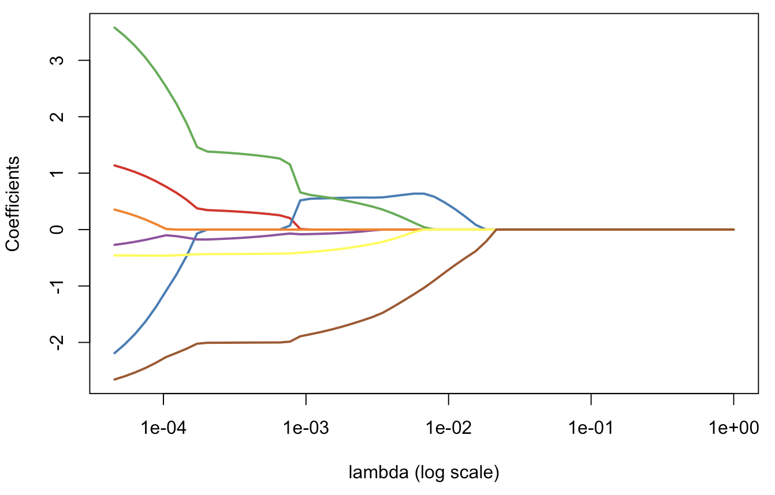

It looks like what can get when calling glmnet… and here, we do have null components for some λ\lambdaλ large enough ! Really null… and that’s cool actually.

**Application on our second dataset**

Consider now the second dataset, with two covariates. The code to get lasso estimates is

|  |
| --- |
| df0 = **df**  df0$y = **as.numeric**(**df**$y)-1  plot\_lambda = **function**(lambda){  m = **apply**(df0,2,**mean**)  s = **apply**(df0,2,**sd**)  **for**(j **in** 1:2) df0[,j] &lt;- (df0[,j]-m[j])/s[j]  reg = glmnet(**cbind**(df0$x1,df0$x2), df0$y==1, alpha=1,lambda=lambda)  u = **seq**(0,1,**length**=101)  p = **function**(x,y){  xt = (x-m[1])/s[1]  yt = (y-m[2])/s[2]  **predict**(reg,newx=**cbind**(x1=xt,x2=yt),type="response")}  v = **outer**(u,u,p)  **image**(u,u,v,**col**=clr10,breaks=(0:10)/10)  **points**(**df**$x1,**df**$x2,pch=19,cex=1.5,**col**="white")  **points**(**df**$x1,**df**$x2,pch=**c**(1,19)[1+z],cex=1.5)  **contour**(u,u,v,**levels** = .5,add=TRUE)} |

Consider some small values, for [\lambda], so that we only have some sort of shrinkage of parameters,

|  |
| --- |
| reg = glmnet(**cbind**(df0$x1,df0$x2), df0$y==1, alpha=1)  **par**(mfrow=**c**(1,2))  **plot**(reg,xvar="lambda",**col**=**c**("blue","red"),lwd=2)  **abline**(v=**exp**(-2.8))  plot\_lambda(**exp**(-2.8)) |

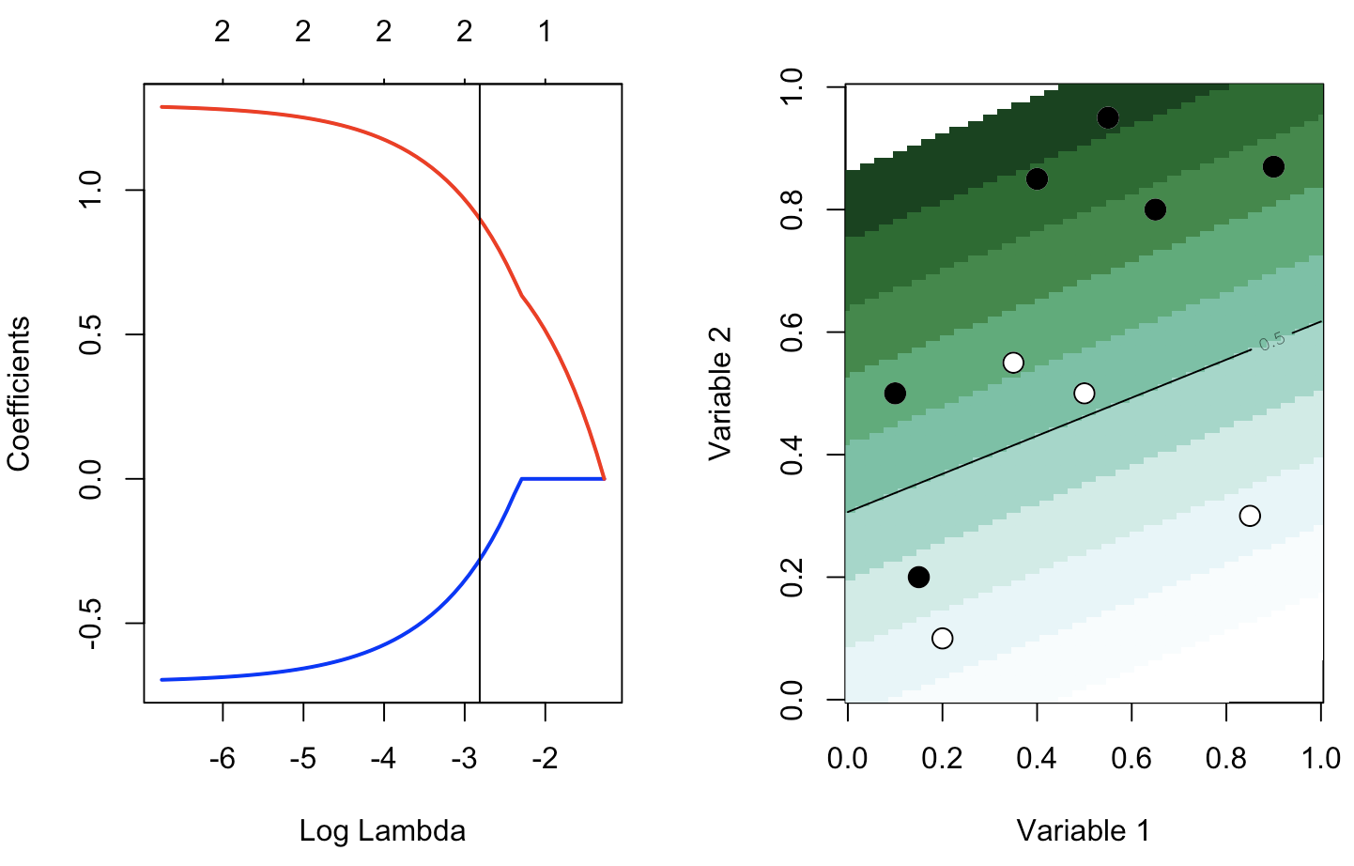  
But with a larger λ\lambdaλ, there is variable selection: here β^1,λ=0\widehat{\beta}\_{1,\lambda}=0β

​1,λ​=0

|  |
| --- |
| reg = glmnet(**cbind**(df0$x1,df0$x2), df0$y==1, alpha=1)  **par**(mfrow=**c**(1,2))  **plot**(reg,xvar="lambda",**col**=**c**("blue","red"),lwd=2)  **abline**(v=**exp**(-2.1))  plot\_lambda(**exp**(-2.1)) |

